Data Scientist Assignment Solution
Q1)
Read the below document using R
https://s201.q4cdn.com/262069030/files/doc_financials/2023/ar/Walmart-10K-Reports-Optimize
d.pdf
Solution:
Code and output:

library(pdftools)
text <- pdf_text("C:/Users/Admin/Downloads/Walmart-10K-Reports-Optimized.pdf")
cat(text)
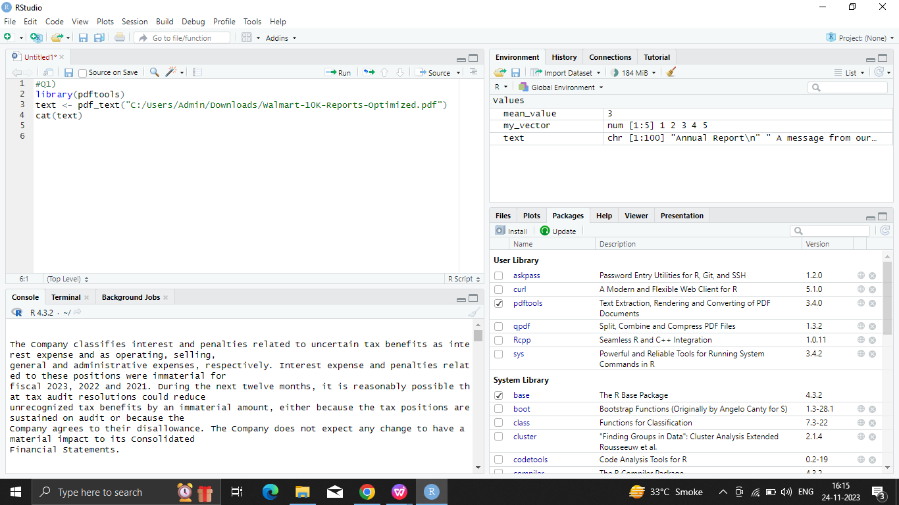
First we installed the pdftools package and using Library(pdftools) we run the package
We copy the path the desired file and paste it by assigning it to a variable
The cat(text) helps us to print the extracted text

Q2)
Read the income statement table on page 54 using R
Solution:
Code:
library(pdftools)
pdf_path <- "C:/Users/Admin/Downloads/Walmart-10K-Reports-Optimized.pdf"
text <- pdf_text(pdf_path)

text_page_56 <- text[56]
cat(text_page_56)

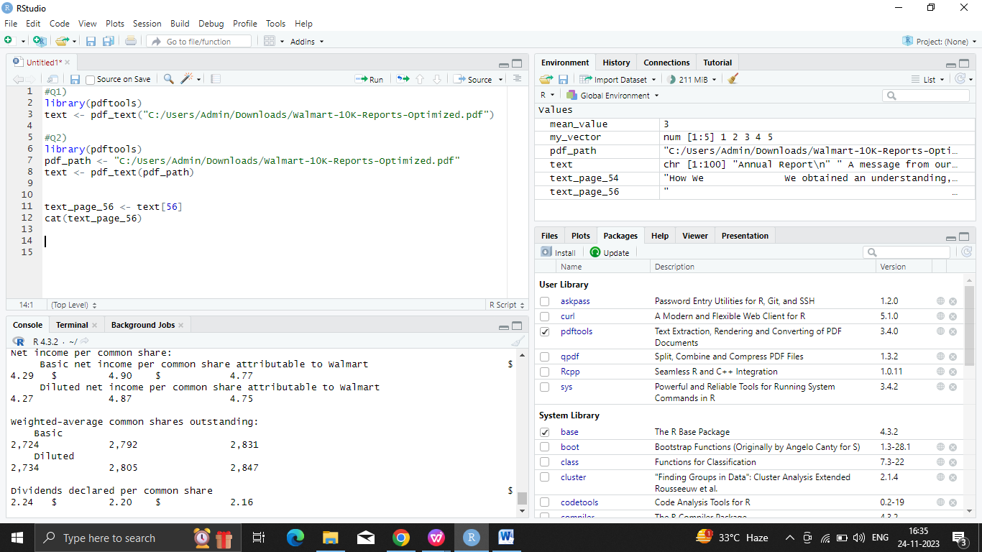
Output:
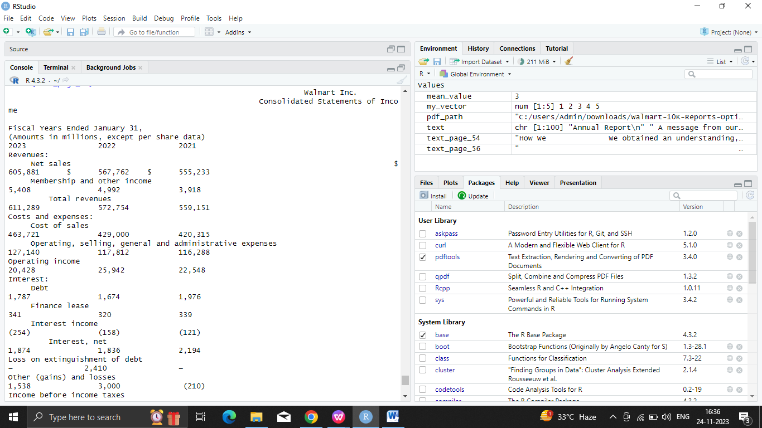
Q3)
Do any data manipulation/processing if necessary to bring the income statement table
(which you read in step 2) in a table format so that any downstream analysis like year
over year can be done.
Soluton:

Code:
lines <- strsplit(text_page_56, "\n")[[1]

lines <- lines[lines != ""]
start <- grep("Revenues:", lines)
end <- length(lines)
table_lines <- lines[(start + 1):end]
table_lines <- lines[(start + 1):end]
income_data <- strsplit(table_lines, "\\s+")
income_df <- data.frame(matrix(unlist(income_data), nrow = length(income_data), byrow = TRUE))
colnames(income_df) <- income_df[1, ]
income_df <- income_df[-1, ]
income_df <- apply(income_df, 2, function(x) as.numeric(gsub("[^0-9.-]", "", x)))
print(income_df)
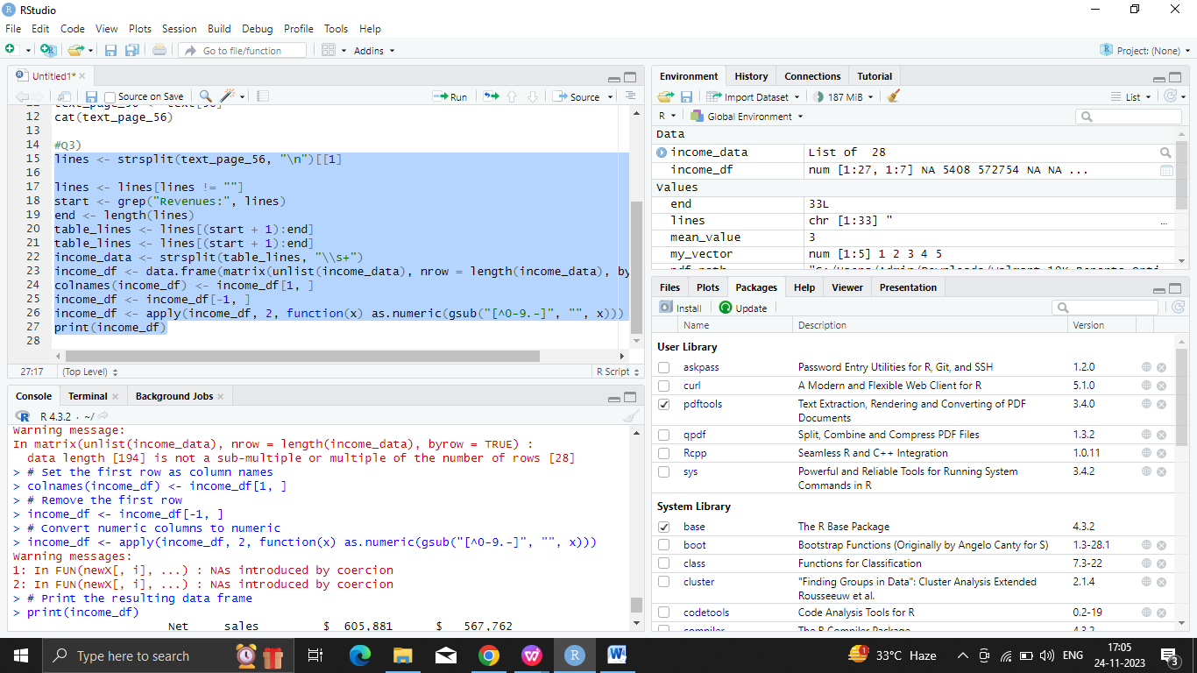
Output:
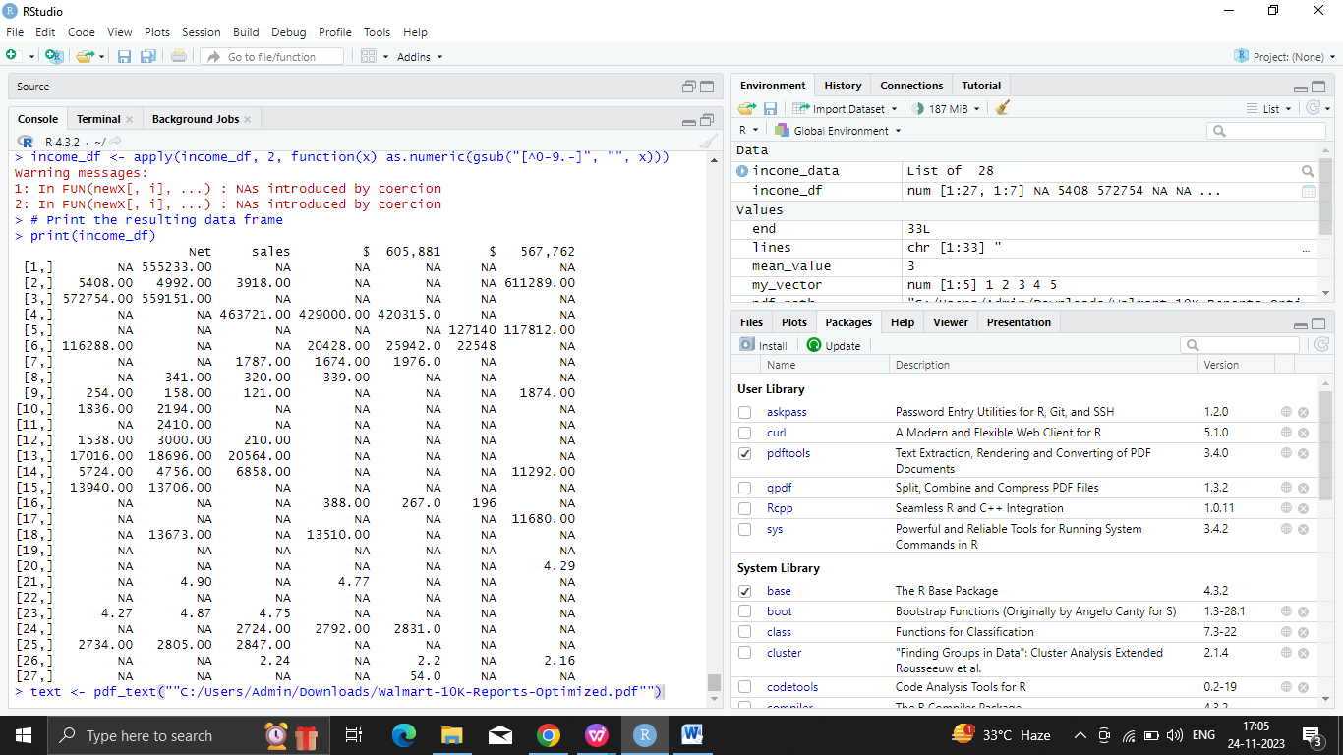
First I split the text into two lines , then I removed the empty lines , I found the start and end of the table and extracted the relevant lines , Split each line into columns based on whitespace, following that I created a dataframe , Converted numeric columns to numeric and printed the data frame

